- Search a place in school: Customer logs into the JagTrack system and chooses the function of search place. System presents results on the map.

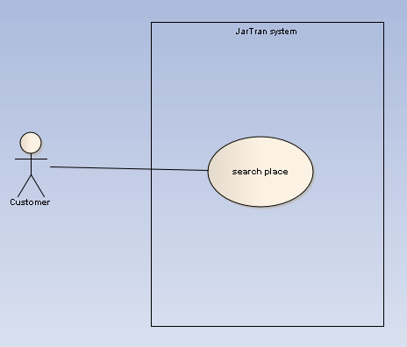

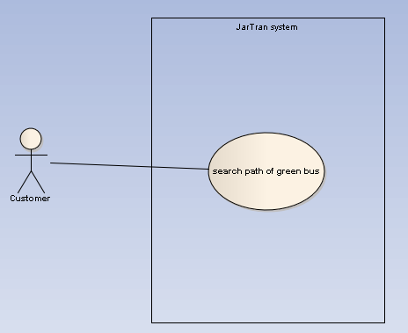
- Search the path of green bus: Customer logs into the JagTrack system and chooses the function: search the path of the green bus line. System presents results on the map.

